**Professional Online Services at Doorstep**

**Group Members:-**

**Vipul Barhate**

**Swapnil Potdar**

**Siddhesh Patil**

**Komal Wani**

**Project Guide:-**

**Pooja Jaiswal Mam**

* **Purpose :**

Along with time and cost, convenience is a pertinent factor that influences consumers to purchase services. For the majority of the people, it is hard to find the trustworthy and experienced professional for their in-house work and even after they got one, there is no guarantee that the workers will be available on the same date and time as customer want. Professionals are also struggling to find work. Therefore, to solve these problems, our application platform can be found as a medium to resolve it. Through our platform user can find professionals for their in-house work through various categories of our application and also the professionals can also find some work.

* **Scope of Project:**
* The main objective of our project is to provide job to unemployed, talented, trustworthy people and also to provide instant services to our customers.
* Our platform can provide the services to the users as well as professionals.
* It provides a platform that allows skilled and experienced professionals to connect with the users looking for specific service.
* It enables users to find any service professionals like Repairers, Painters and Cleaners etc. which are listed on our platform.
* Our platform is the best way that a small business can reach with the seekers through our application and connect with the local audience by showing their services online.
* This system also acknowledges the confirmation of services chosen by the users.
* The system will store all the database records of Customers, Professionals, and the hire request should be available for use 24*7 through the server.
* All login ids and passwords of the Admin, Employee and Customer will be protected for privacy using whatever constraints required in the database or the application.
* **Workflow:-**
* **For Customer:-**



* **For Admin:-**



* **Use-case Diagram**:-

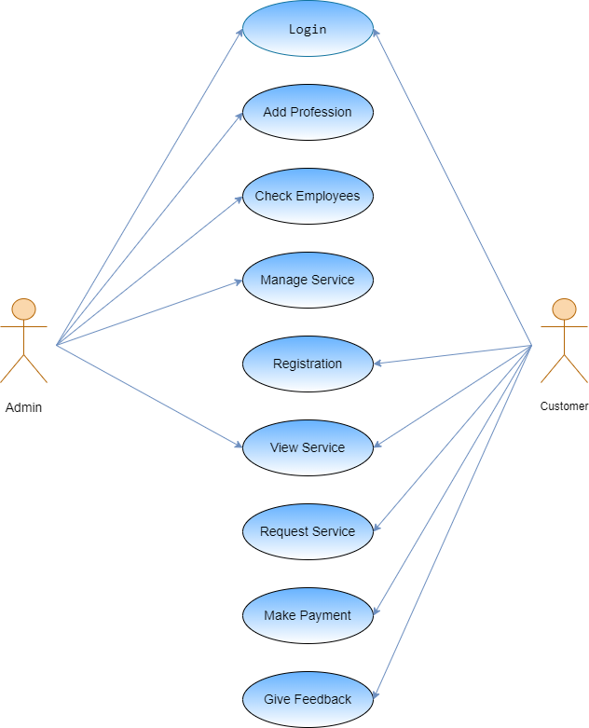

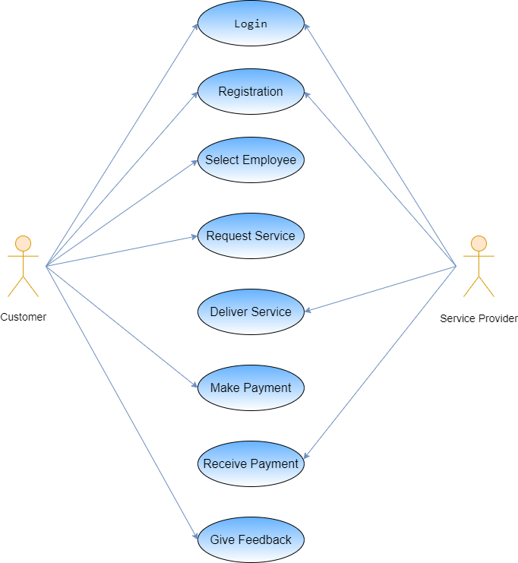

* **UI design/Web Pages:-**
* **Home Page:-**



* **Our Services Page:-**

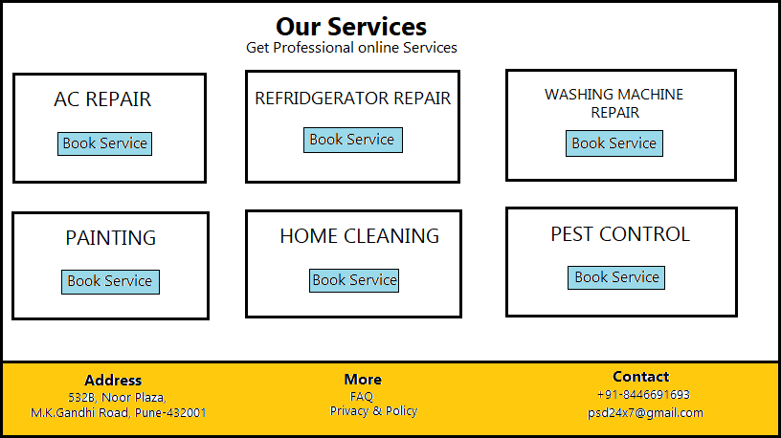

* **About Us Page:-**

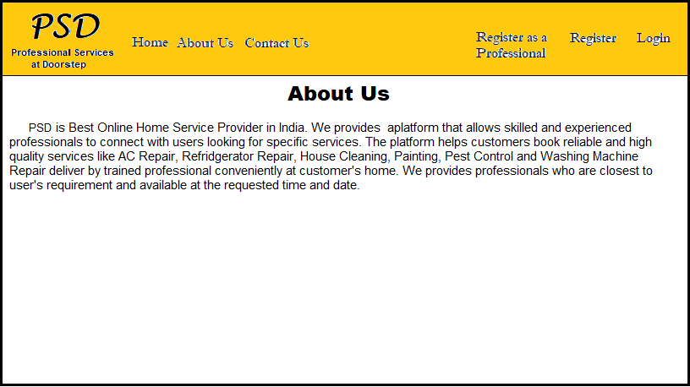

* **Login Page:-**

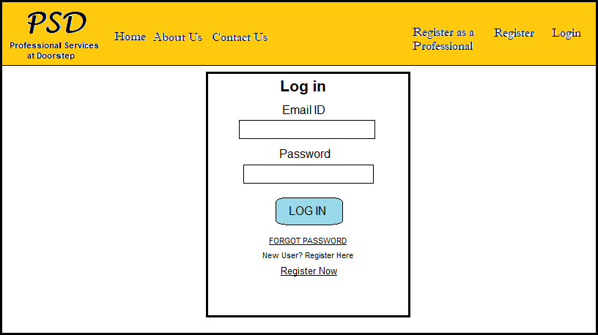

* **Customer Registration Page:-**

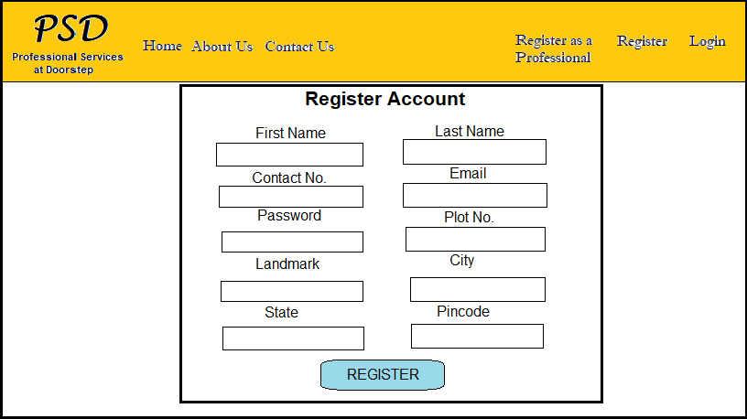

* **Employee Registration Page:-**

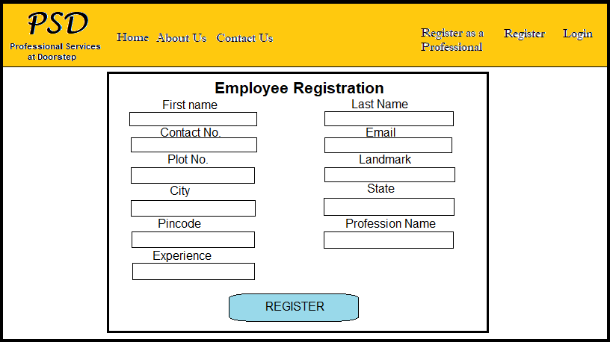

* **Admin Profile:-**

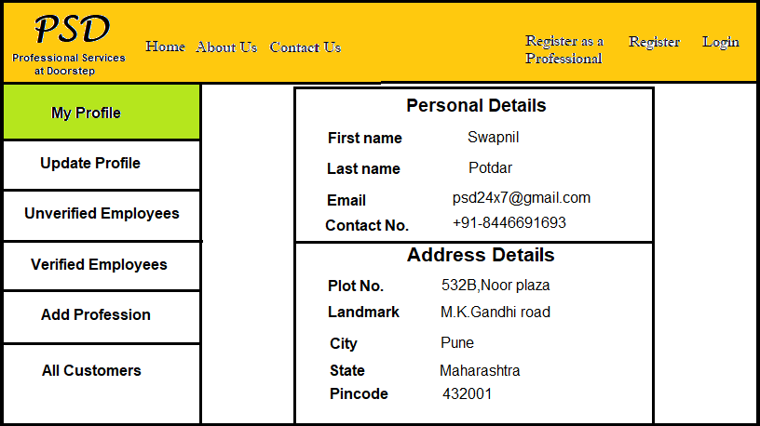

* **Unverified Employees Page:-**

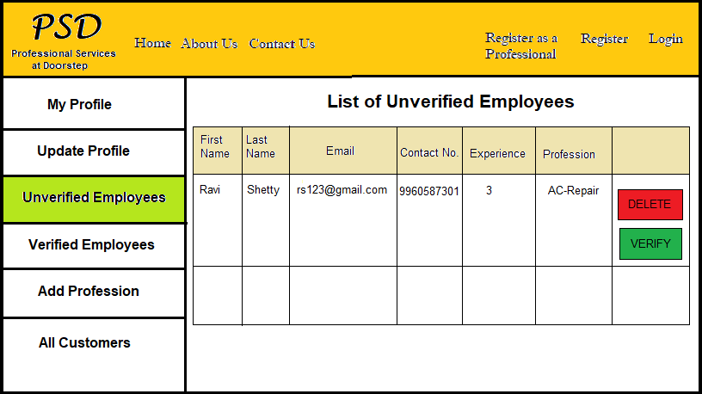

* **Verified Employees Page:-**

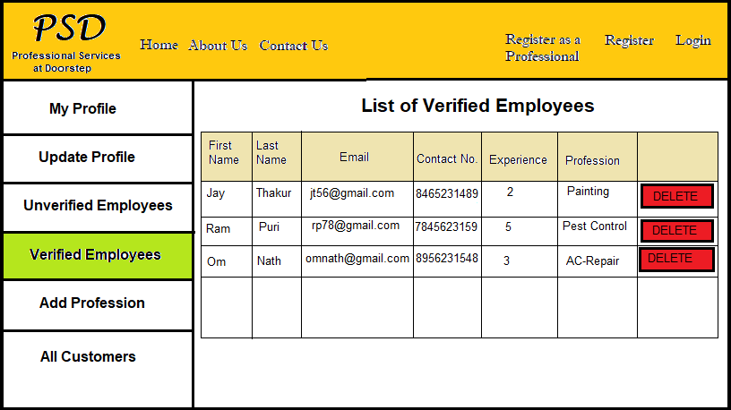

* **Add Profession Page:-**

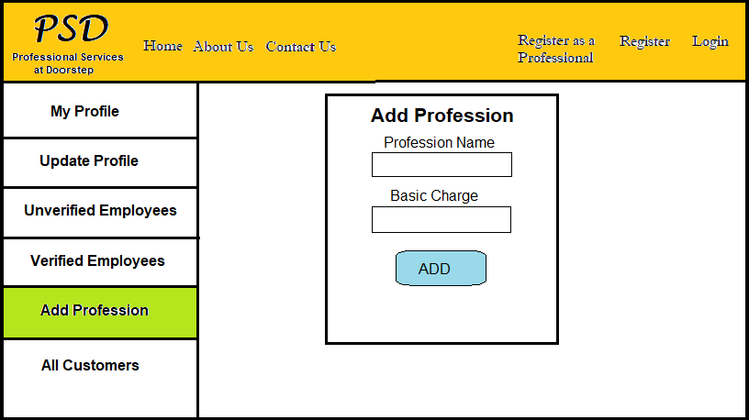

* **All Customers Page:-**

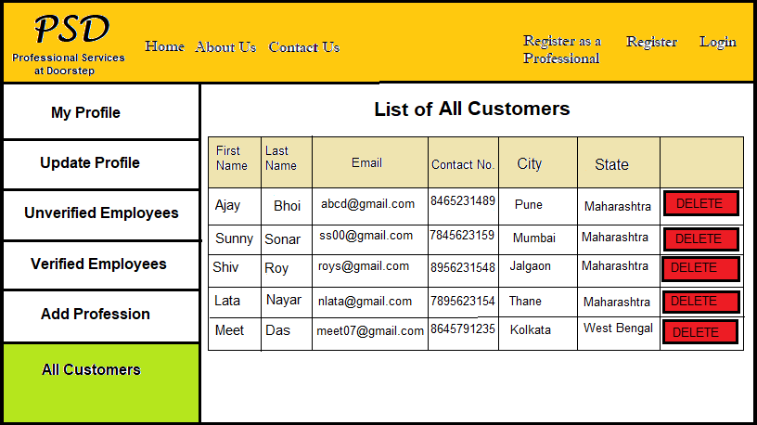

* **Customer Profile Page:-**

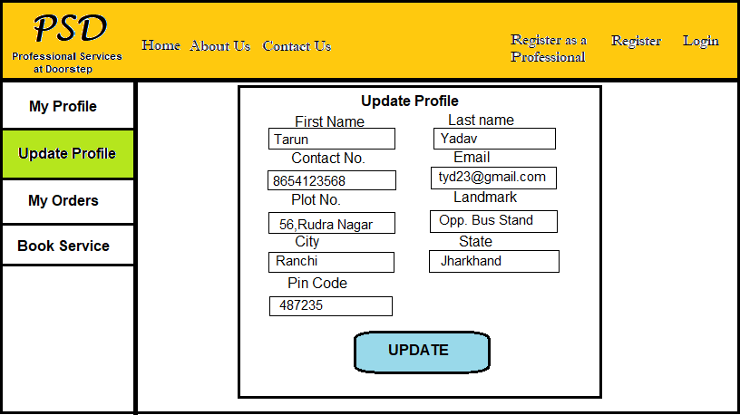

* **Order Status Page:-**

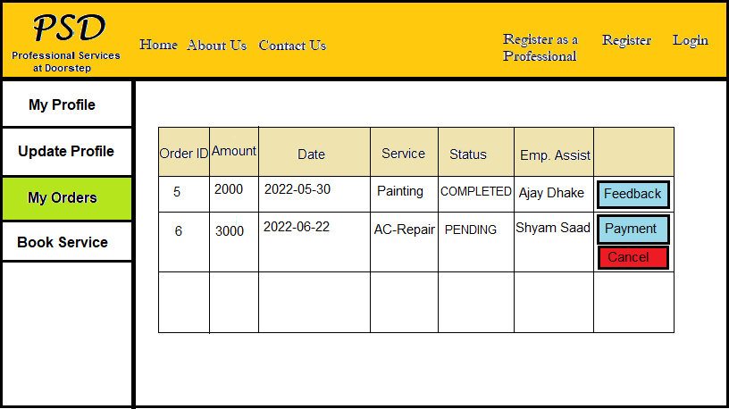

* **Book Service Page:-**

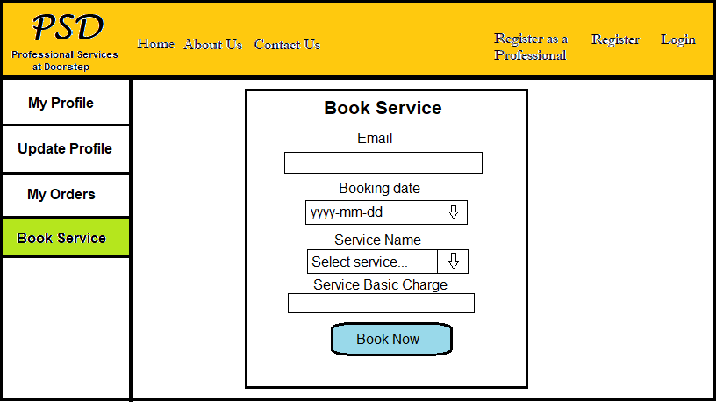

* **Database Design:-**
* 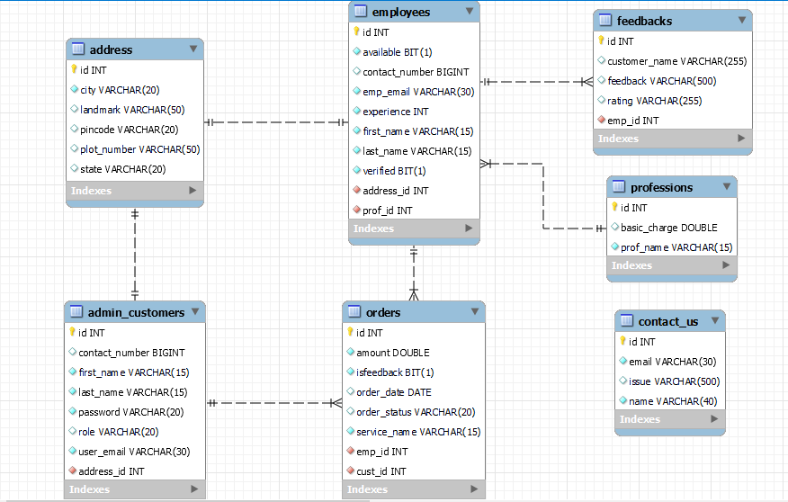**ER Diagram:-**

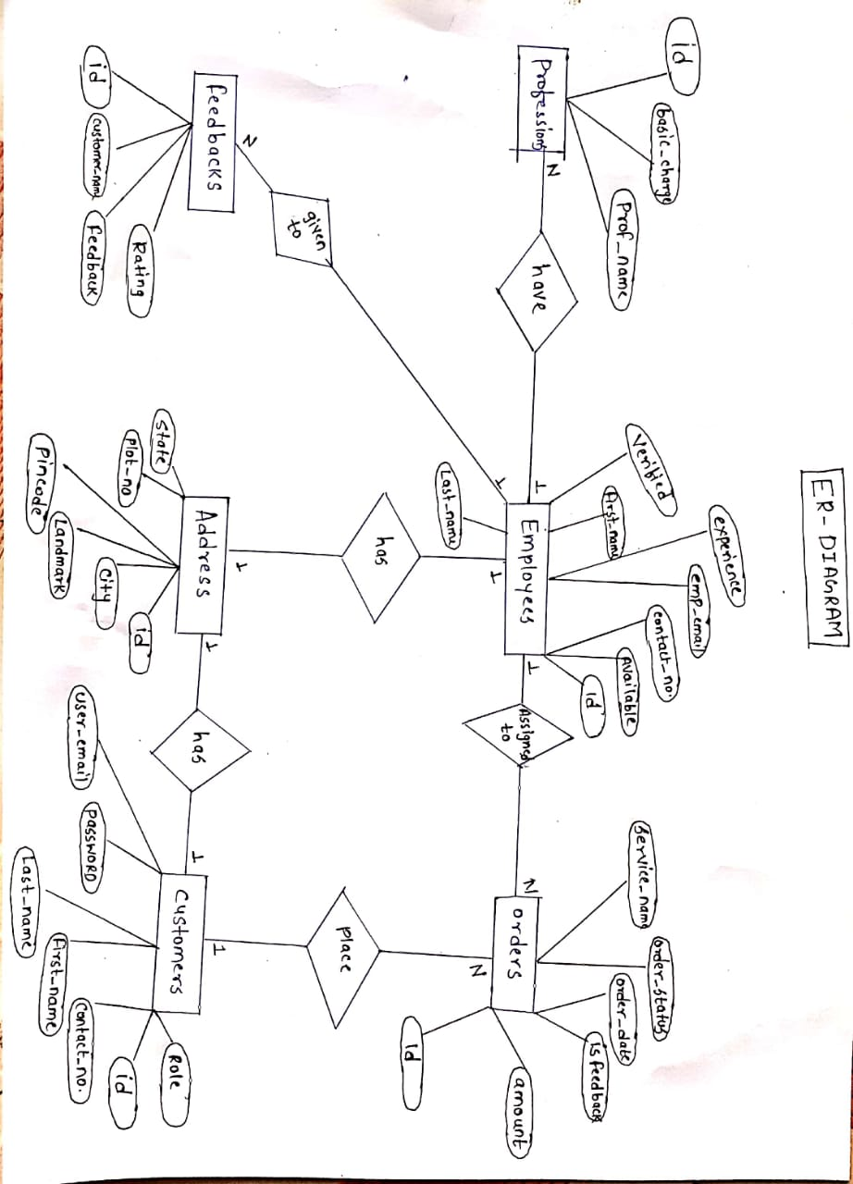

* **Database Design:-**

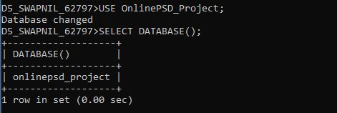

* **List of Tables:-**

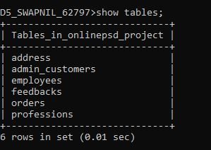

* **Address Table:-**

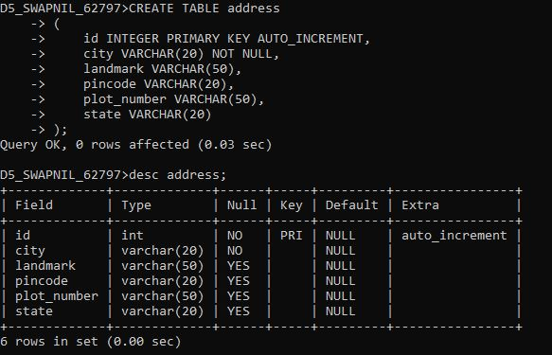

* **Admin_customers Table:-**

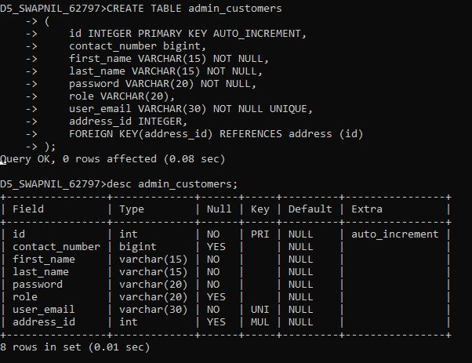

* **Employees Table:-**

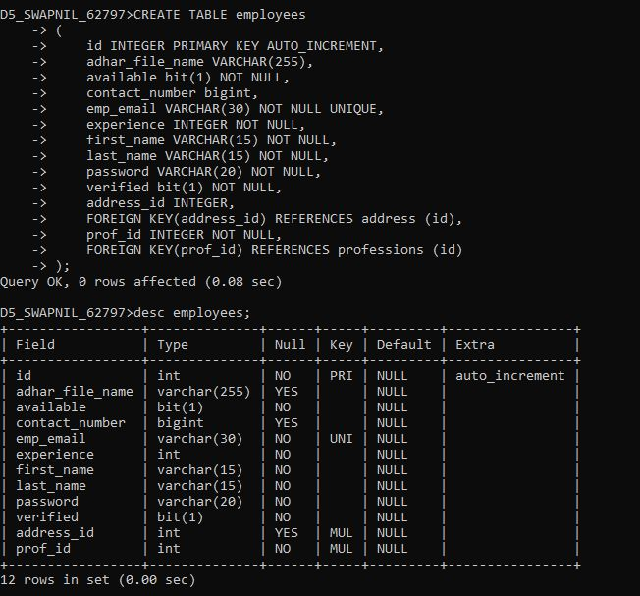

* **Feedbacks Table:-**

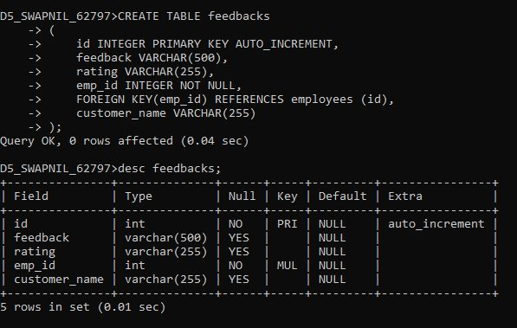

* **Orders Table:-**

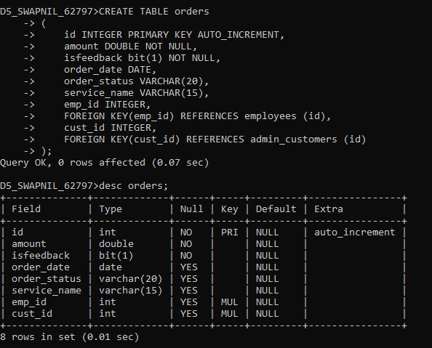

* **Professions Table:-**

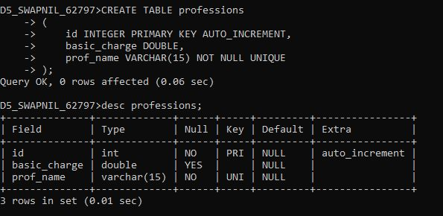

* **Class Diagram:-**

